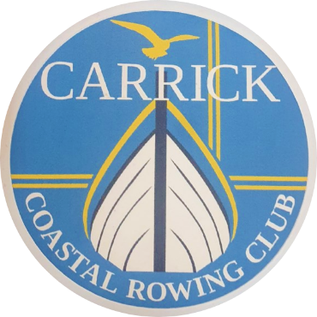
CARRICK COASTAL ROWING CLUB
MEMBERSHIP APPLICATION FORM

- Membership of Carrick Coastal Rowing Club is available in the TWO categories, shown below:

ORDINARY – Full adult membership - £50.00 annually.

JUNIOR/STUDENT - Under 16 years of age or in education - £15.00 annually.
(proof of age, parental signature and/or student cards may be requested)

- In taking membership you are acknowledging your acceptance and understanding that all members, guests and visitors of the club use the facilities entirely at their own risk. Carrick Coastal Rowing Club will not accept liability for any damage to or loss of property belonging to members, their guests or visitors to the club.

- Rowing is undertaken at your own risk, and it is your responsibility to always declare any injuries, illnesses or disabilities that may make yourself unfit and/or unwell for rowing. You have a duty to declare any condition that might put yourself or others at risk. Likewise you have a duty to declare any change in personal health that may put yourself or others at risk.

- Lifejackets are provided by the club and must be worn at all times whilst at sea.

- Membership of the Club and acceptance of the constitution by the member will be deemed to constitute consent to the holding of relevant personal data for the purposes of the Data Protection Acts.

APPLICATION FOR MEMBERSHIP

CALENDER YEAR OF MEMBERSHIP: 2022
Type of membership (please circle): ORDINARY £50 JUNIOR/STUDENT £15

Surname: First Name Title:
Address:
Postcode:
Tel Home Mobile:
Email Address:

Please read the sections overleaf and sign the declaration.
Completed forms should be sent to: carrickcoastalrowing@hotmail.com and electronic payment sent to -
Sort code 80-22-60 Account 14377366 (reference “your name”)

EMERGENCY DETAILS

Name of persons to contact in an emergency: (please provide at least 1)

- Name: Telephone:

- Name: ___________________________ Telephone: __________________________

Your Personal Health
Rowing can be a strenuous activity. You should therefore be in good health and have no medical or physical condition precluding heavy exercise, if there is any doubt you should first consult your doctor.
Some conditions such as asthma and diabetes, for example, do not prevent individuals participating in the sport, but you do have a duty to declare any condition that might put yourself or others at risk. Likewise you have a duty to declare any change in personal health whilst a member of the Club that may put yourself or others at risk.
It is important therefore that you inform the cox in charge of any condition they may have to deal with in the event of an emergency.

Declaration of Your Personal Health
To be accepted as a member you must sign this declaration.
I have read and understood the Personal Health statement above and I agree to inform the club/cox of any special medical conditions which may affect my ability prior to rowing.
I hereby apply to join Carrick Costal Rowing Club on the basis of the information provided here. I understand that this information will be kept on record during my membership of the Club, that it will be secure and private and that you will use it to keep in touch with me, as required. When my membership is approved, I agree to abide by the terms of the Constitution, Rules and Byelaws

Signature: Date:

Parent/guardian signature for junior membership:

